**SW Engineering CSC648/848 Section 02 Spring 2018**

**Software Engineering Term Project:**

**Cleansweep Application**

Team Number 11 – Local

Brady Helkenn

Jason Guan

Dylan Abrames

Avi Mukherjee

Rodolfo Salgado

Frank Hood

The team is local.

Brady Helkenn bhelkenn@gmail.com

Milestone 2

3-18-2018

|  |  |
| --- | --- |
| History Table | |
| Submitted for review |  |
| Revised after feedback |  |
|  |  |
|  |  |
|  |  |
|  |  |

**DATA DEFINITIONS**

User:

First name

Last name

Email

Username

Password

Title

Hobbies

User:

Name

Zip Code (zip)

Description

City

State

Latitude (lat)

Longitude (log)

Park Issue:

Title

Description

Status

Author

Date

City

State

Image (img)

**FUNCTIONAL REQUIREMENTS**

**Priority 1**

1. All users shall be able to search for Reports by zip code.
2. All users shall be able to search for Reports by Park name.
3. All users shall be able to post images when submitting an environmental incident.
4. All users shall be able to see the status of submitted Reports.
5. All users shall be able to view a park’s location through Google Maps.
6. Unregistered Users shall be allowed to fill out a Report, but must register to submit the report.
7. Registered Users shall be able to log in using a username and password.
8. Registered Users shall be able to save up to five Reports to be displayed while logged in.
9. City Users shall be able to view all Reports submitted by users.
10. City Users and Admins shall be able to view user information attached to submitted Reports.
11. City Users shall be able to adjust the Status of a submitted Report to received, duplicate or undesired depending on the content of the submitted Reported.
12. Admins shall be able to delete submitted Reports.
13. Admins shall not be able to edit submitted Reports.
14. Admins shall be able to deactivate Registered Users’ accounts.

**Priority 2**

1. All users should be able to select a park by viewing the park’s location through Google Maps
2. Registered Users shall be able to reset their password from the sign-in screen.
3. Registered Users shall be able to place a marker on a Google Map to designate the location of an environmental incident

**Priority 3**

1. All users shall be able to view Reports per a zip code sourced from Google maps.
2. All users shall be able to locate parks through markers placed through Google Maps
3. Registered Users shall be able to see markers corresponding to environmental incidents placed by other users.
4. City Users shall be able to contact Registered Users directly when looking at a submitted environmental incident.

**NON-FUNCTIONAL REQUIREMENTS**

1. Application shall be developed, tested and deployed using tools and servers approved by Class CTO and as agreed in M0 (some may be provided in the class, some may be chosen by the student team but all tools and servers have to be approved by class CTO).
2. Application shall be optimized for standard desktop/laptop browsers e.g. must render correctly on the two latest versions of all major browsers: Mozilla, Safari, Chrome.
3. Application shall have responsive UI code so it can be adequately rendered on mobile devices but no mobile native app is to be developed
4. Data shall be stored in the team’s chosen database technology on the team’s deployment server.
5. Application shall be media rich (at minimum contain images and maps)
6. No more than 50 concurrent users shall be accessing the application at any time
7. Privacy of users shall be protected and all privacy policies will be appropriately communicated to the users.
8. The language used shall be English.
9. Application shall be very easy to use and intuitive.
10. Google analytics shall be added
11. No e-mail clients shall be allowed
12. Pay functionality, if any (e.g. paying for goods and services) shall not be implemented nor simulated.
13. Site security: basic best practices shall be applied (as covered in the class)
14. Modern SE processes and practices shall be used as specified in the class, including collaborative and continuous SW development
15. The website shall prominently display the following exact text on all pages *"SFSU Software Engineering Project, Spring 2018. For Demonstration Only”* at the top of the WWW page. (Important so as to not confuse this with a real application).

**UI MOCKUPS and STORYBOARDS**

Use Case 1:

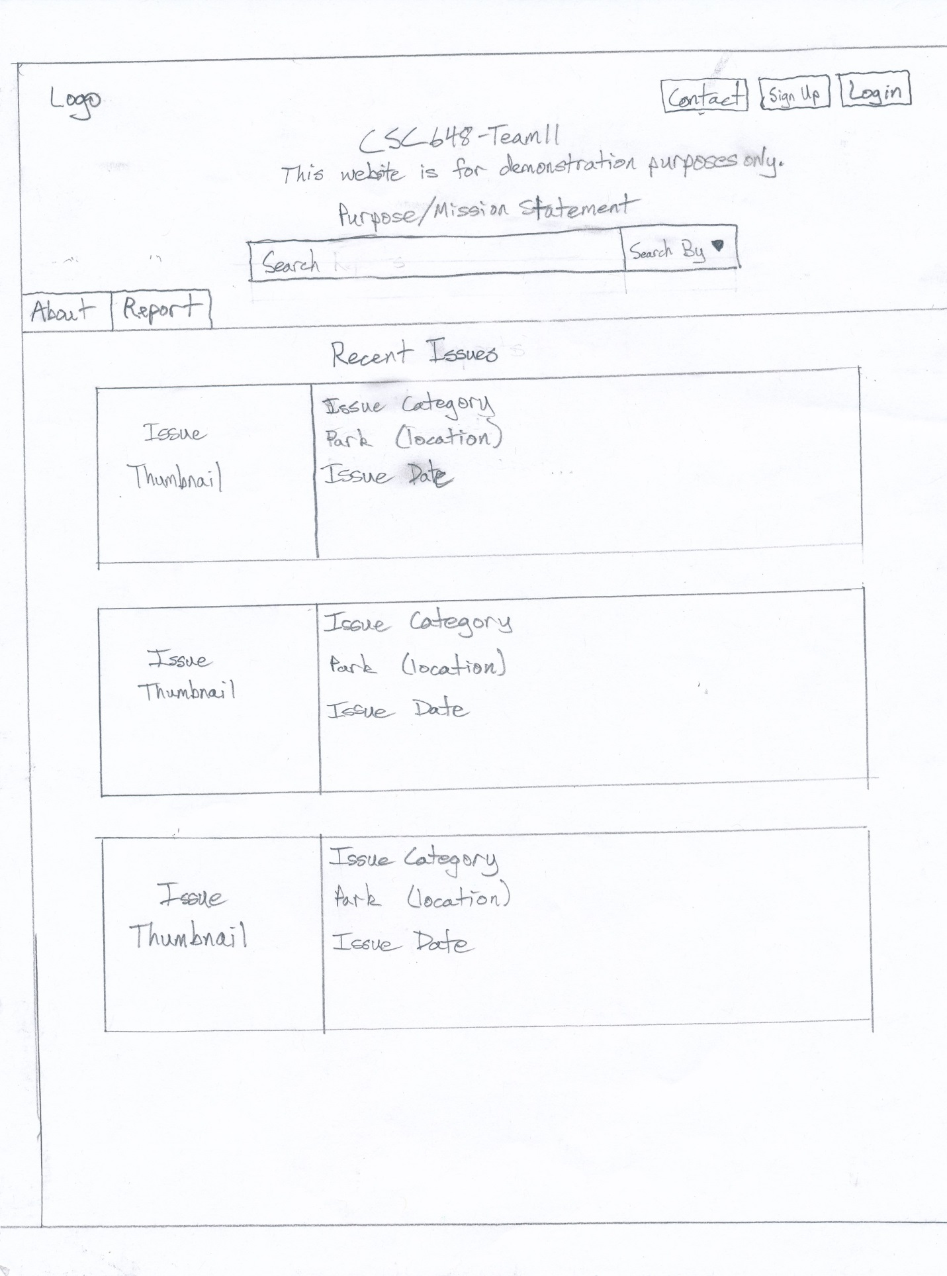

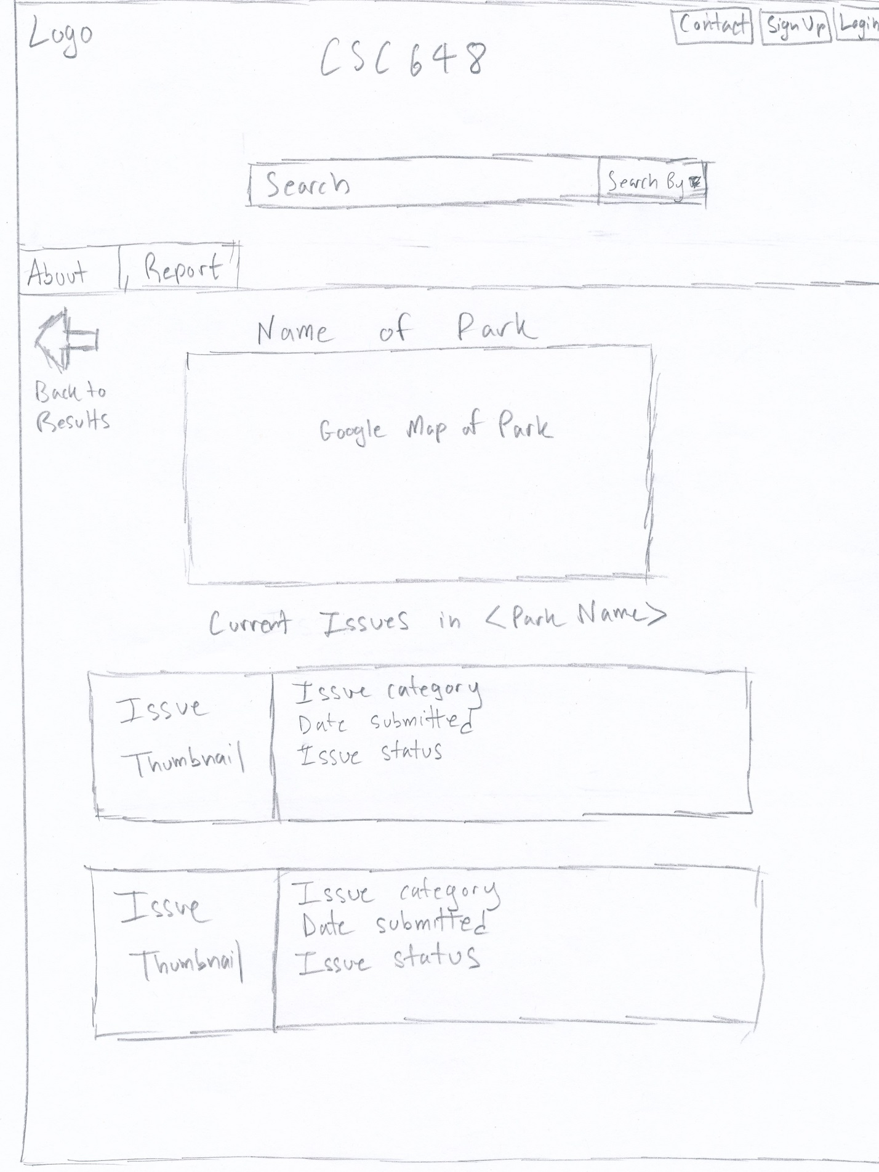

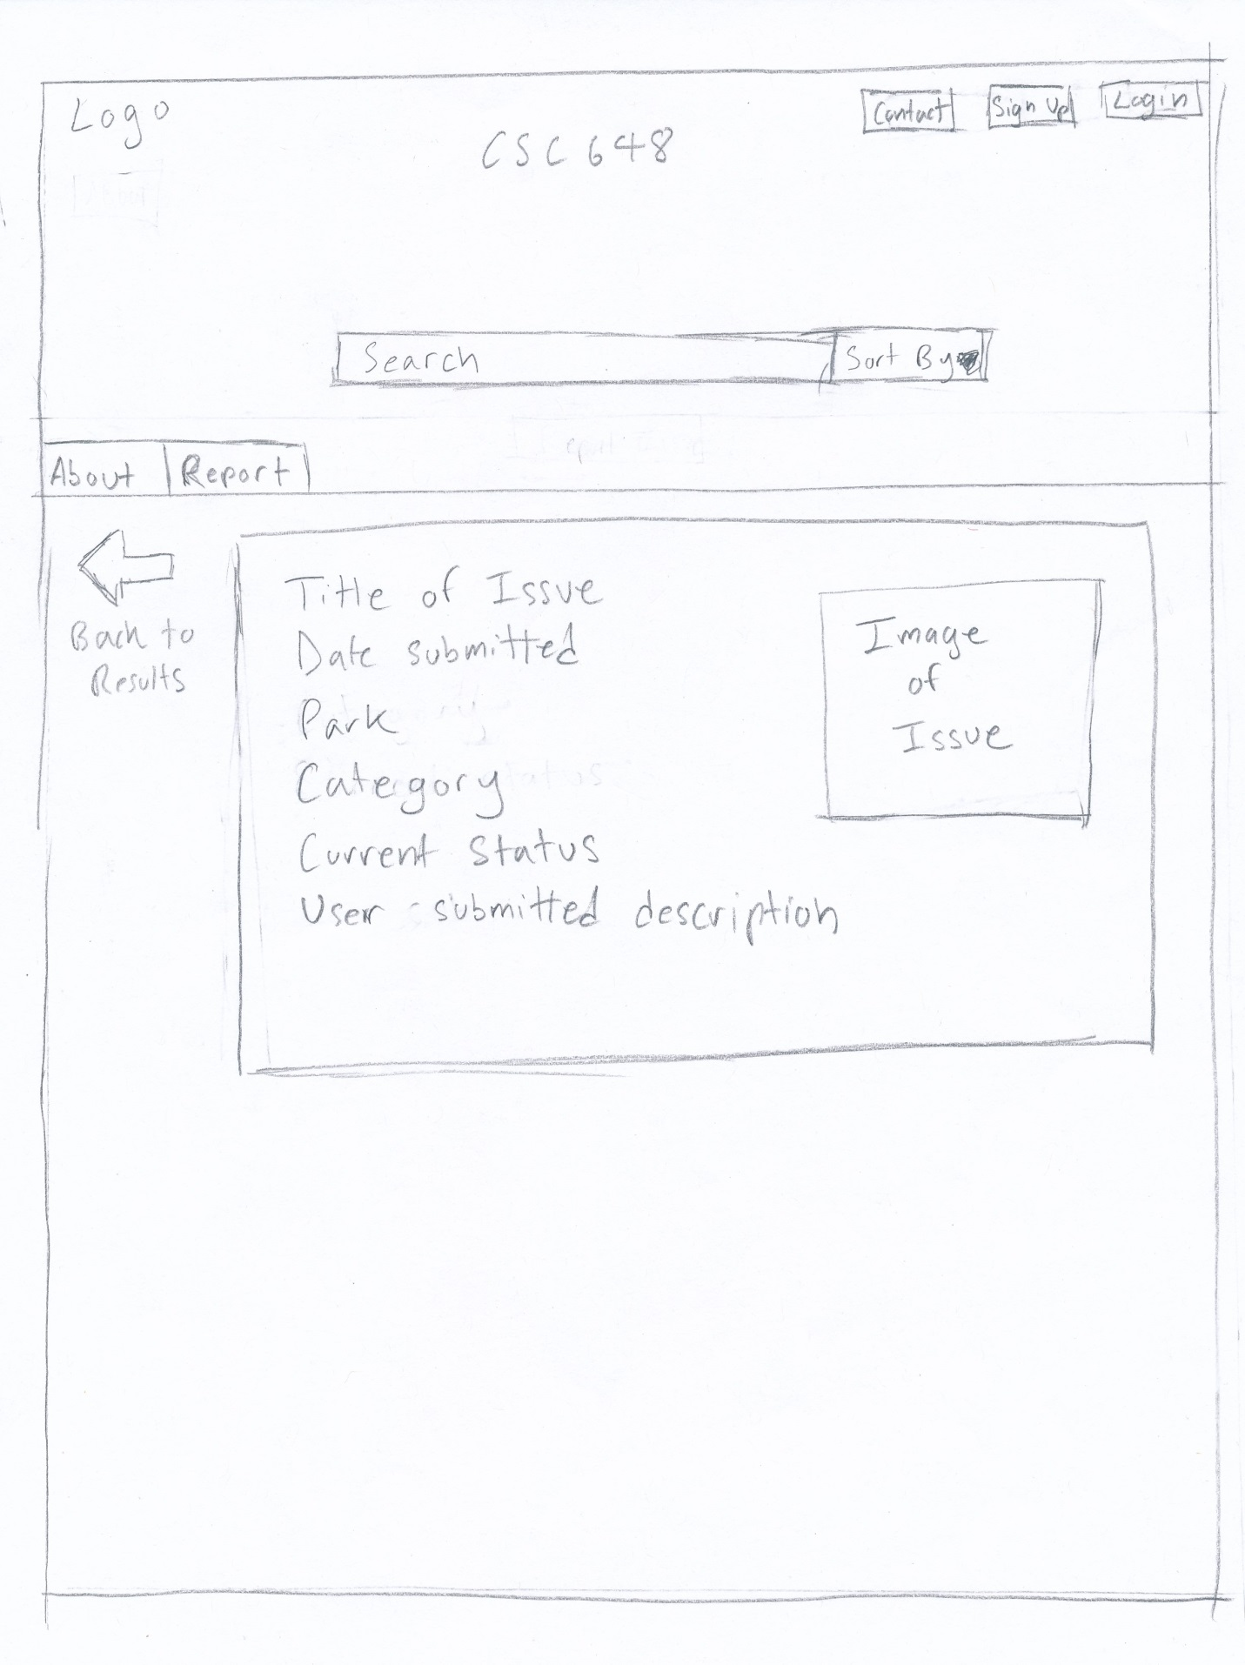

Use Case 2:

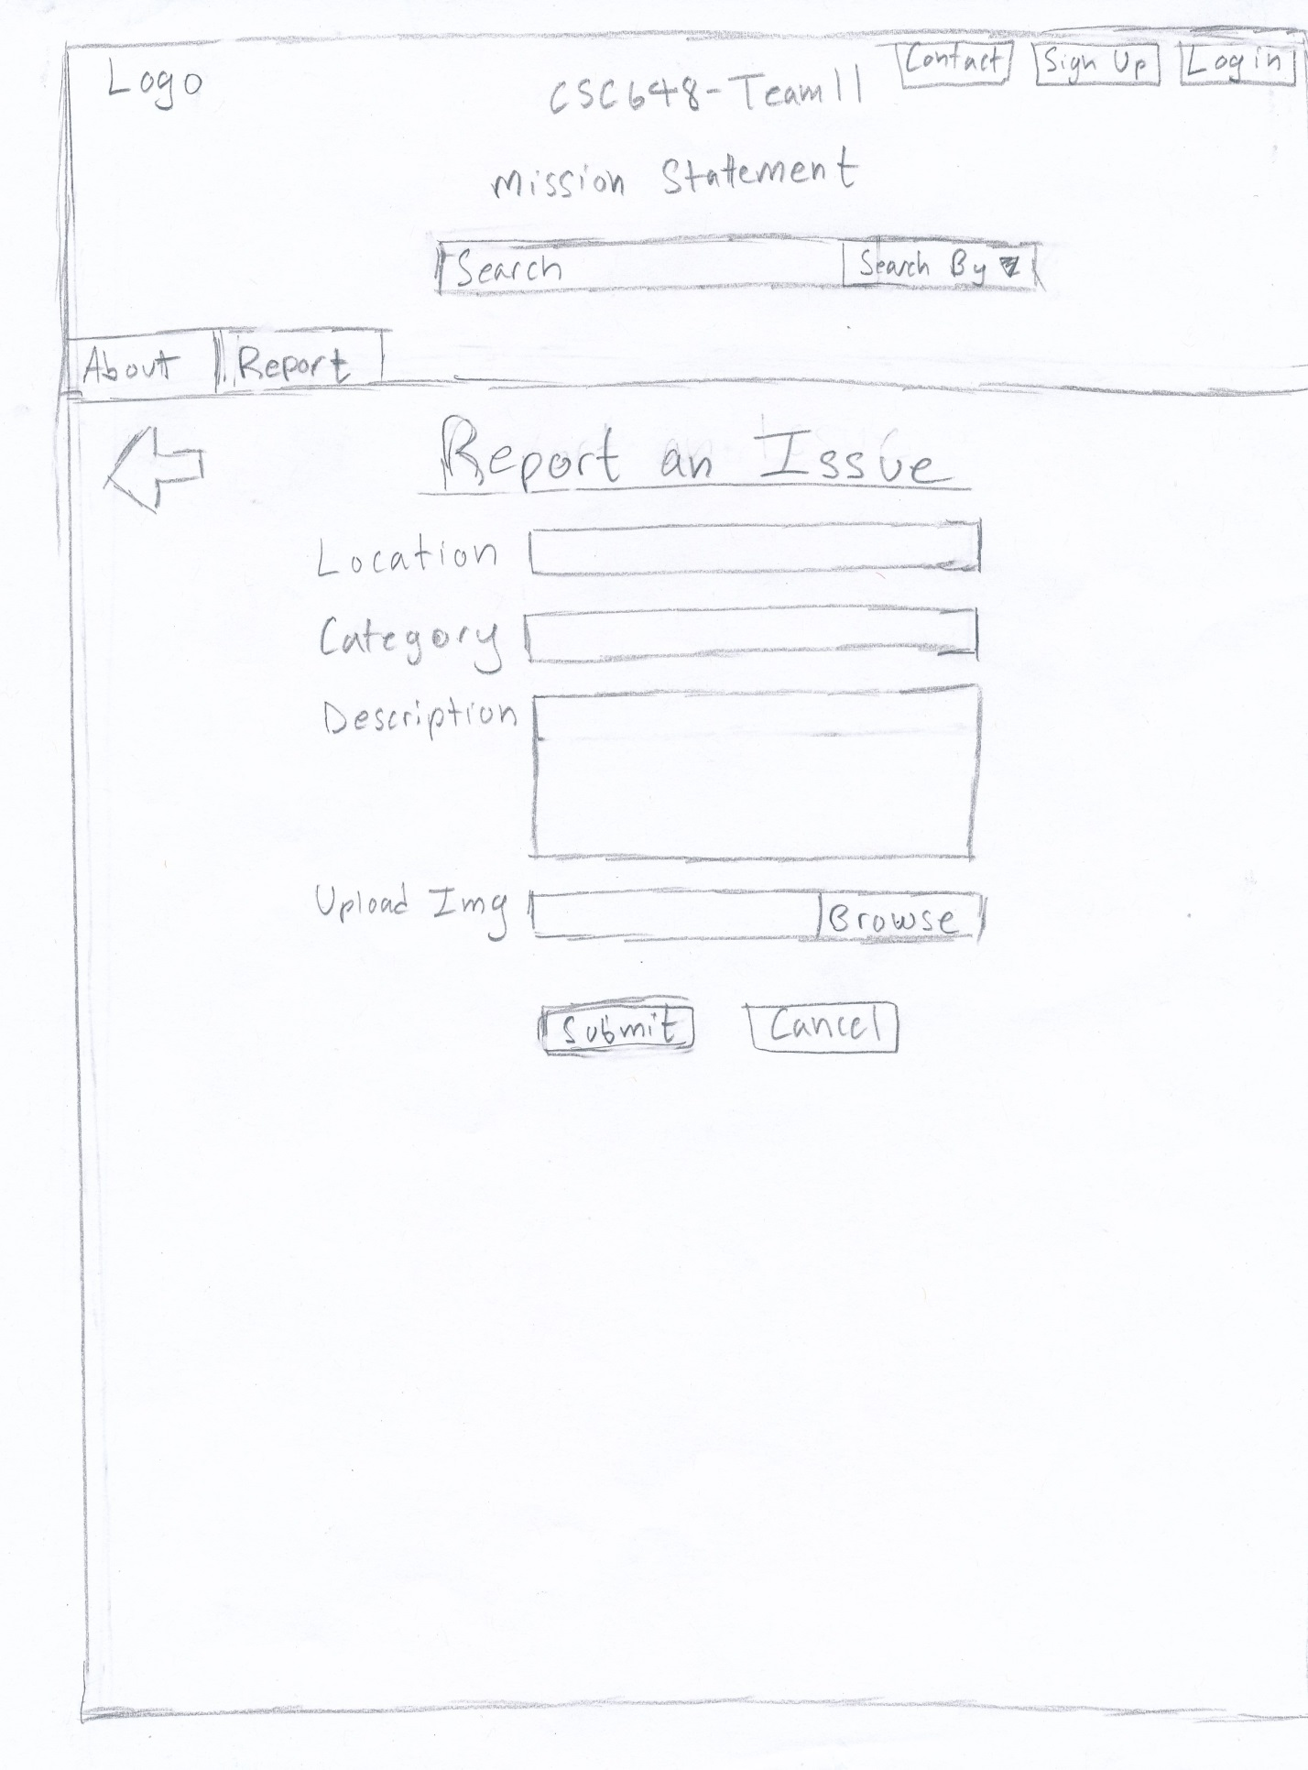

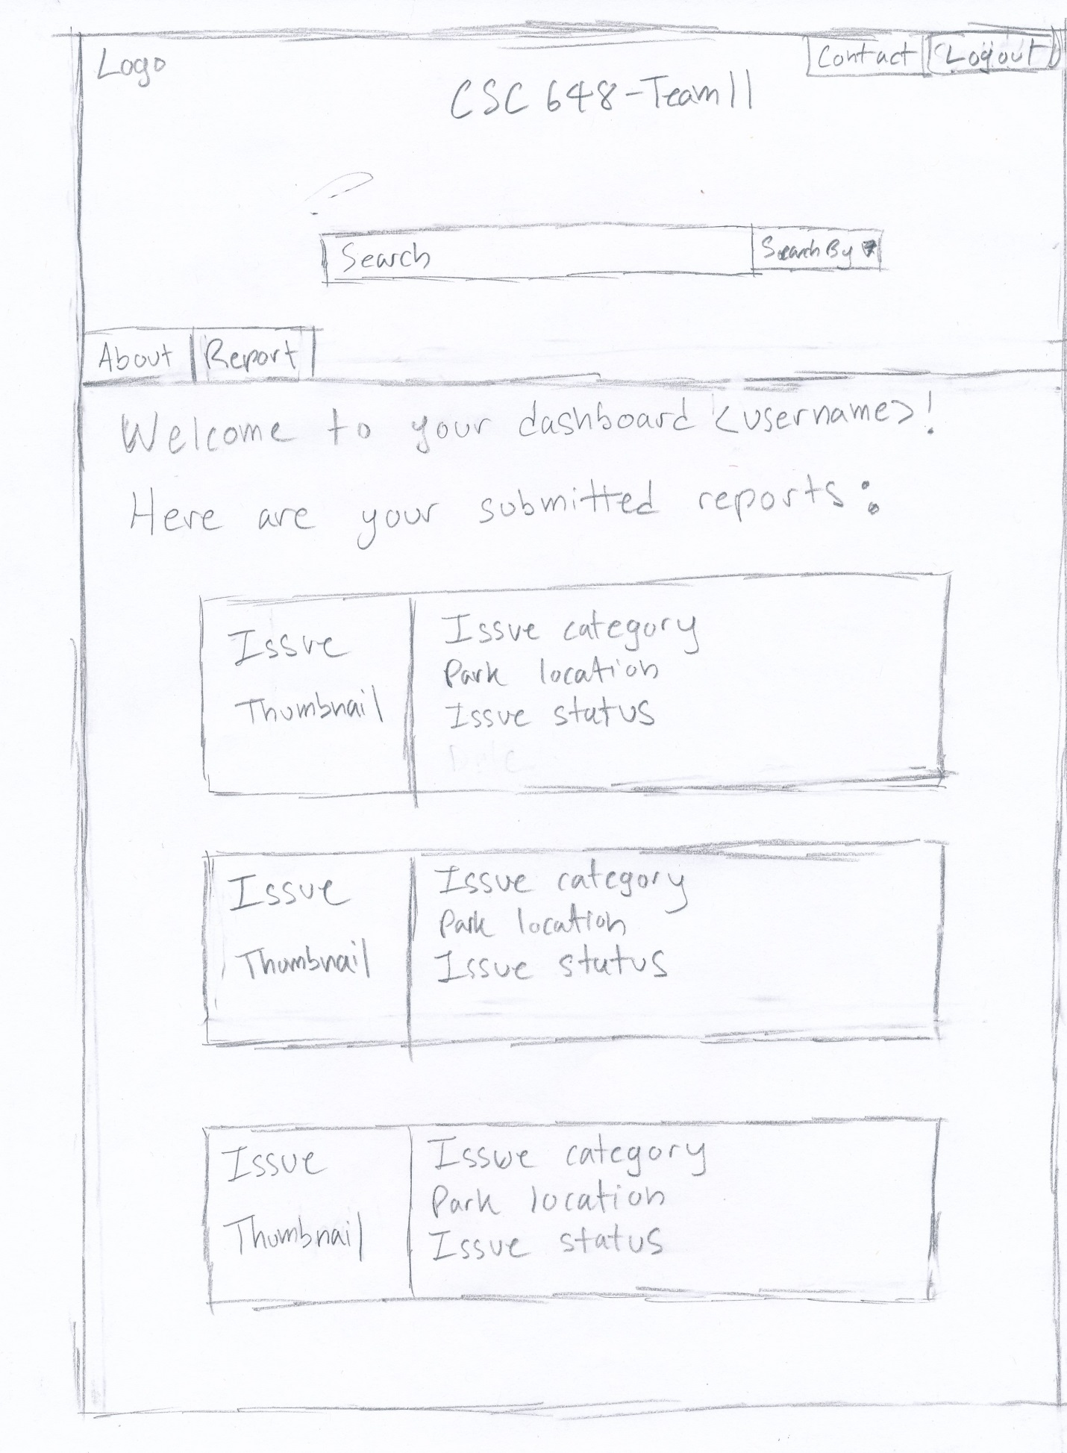

Use Case 3:

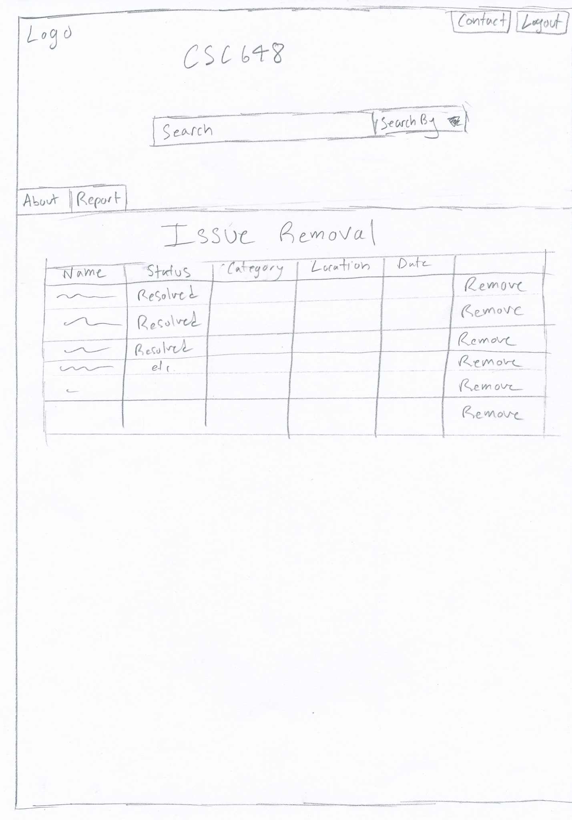

Use Case 4:

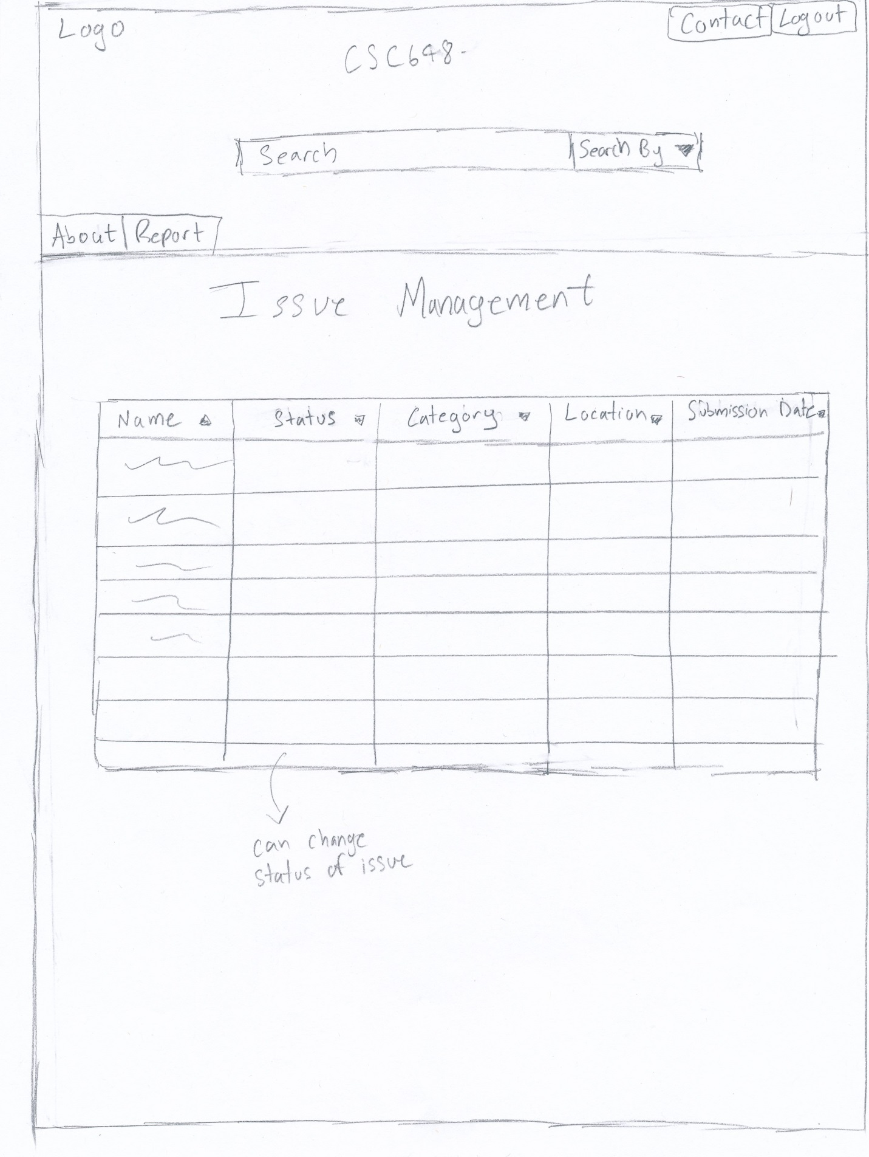

High Level Architecture, Database Organization

Content for vertical prototype

1. Other

2. Biohazard like feces (dog poop/other poop)

3. Dry spill (unidentified powder)

4. Wet spill (unidentified wet spill)

5. Oil spill (oil is easy to identify)

High Level UML Diagrams

**KEY RISKS**

**Skills:**

Team is unsure how to design UML.

**Steps Planned:** Avi and Jason are now collaborating on UML rather than just Jason.

Team is largely unfamiliar with Handlebars.

**Steps Planned:** Planning better documentation for files, and Rodolfo is training Jason on the back-end to better understand it. Dylan has also been familiarizing himself more and can help Avi in turn on the Front End.

Frank is unfamiliar with programming languages in general.

**Steps Planned:** Frank is mostly focusing on documentation and QA.

**Scheduling:**

Brady has a very tight schedule with work, personal issues, and other classes, and is concerned about having sufficient time to continue guiding team progress towards Milestone deliverables safely.

**Steps Planned:** Team has implemented a project management app called Asana to help manage tasks and assignments, with respective due dates, to better organize.

In general, we are somewhat concerned about having sufficient time for addressing QA.

**Steps Planned:** Frank has been assigned overall responsibility for now to run QA tests on live site every few days and put in feedback accordingly.

**Technical:**

Back-end has concerns over how to implement database setup correctly and cleanly.

**Steps Planned:** Dylan will help out Jason on back-end for the moment to help resolve this hurdle.

Front-end has concerns over how to properly secure code.

**Steps Planned:** Will restrict access to database behind DB credentials, while keeping good validation of input from website fields.